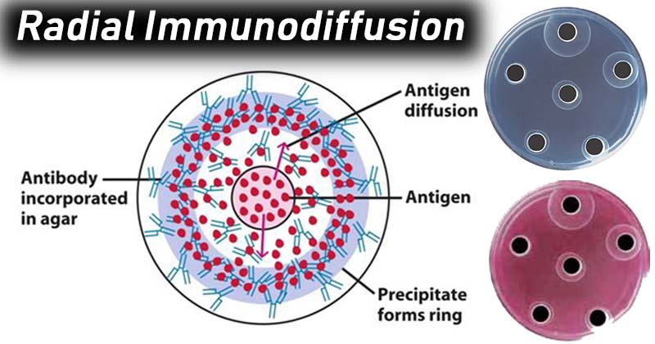
.

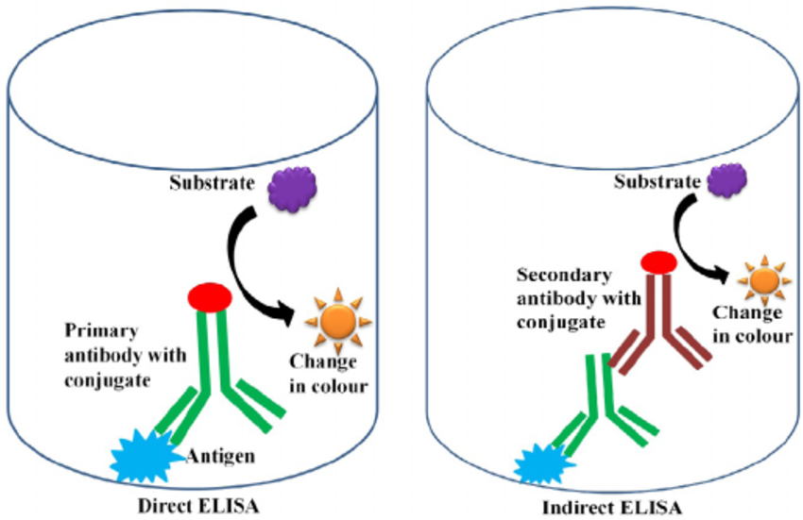

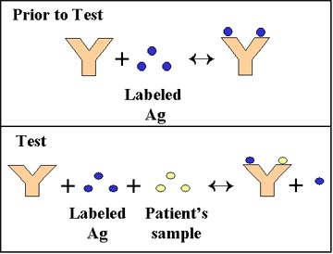

Hodgkin's lymphoma (HL) is a type of lymphoma in which cancer originates from a specific type of white blood cells called lymphocytes.^{[8]} Symptoms may include fever, night sweats, and weight loss.^{[2]} Often there will be non-painful enlarged lymph nodes in the neck, under the arm, or in the groin.^{[2]} Those affected may feel tired or be itchy.^{[2]}
Risk factors
Factors that can increase the risk of Hodgkin's lymphoma include:
- Your age. Hodgkin's lymphoma is most often diagnosed in people between 15 and 30 years old and those over 55.
- A family history of lymphoma. Having a blood relative with Hodgkin's lymphoma or non-Hodgkin's lymphoma increases your risk of developing Hodgkin's lymphoma.
- Being male. Males are slightly more likely to develop Hodgkin's lymphoma than are females.
- Past Epstein-Barr infection. People who have had illnesses caused by the Epstein-Barr virus, such as infectious mononucleosis, are more likely to develop Hodgkin's lymphoma than are people who haven't had Epstein-Barr infections

Non-Hodgkin lymphoma (NHL) is a group of blood cancers that includes all types of lymphoma except Hodgkin's lymphomas.^{[1]} Symptoms include enlarged lymph nodes, fever, night sweats, weight loss and tiredness.^{[1]} Other symptoms may include bone pain, chest pain or itchiness.^{[1]} Some forms are slow-growing, while others are fast-growing.^{[1]}
Lymphomas are types of cancer that develop from lymphocytes, a type of white blood cell.^{[2]} Risk factors include poor immune function, autoimmune diseases, Helicobacter pylori infection, hepatitis C, obesity and Epstein-Barr virus infection

People with weakened immune systems have an increased risk for NHL. For example:
- People who receive organ transplants are treated with drugs that suppress their immune system to prevent it from attacking the new organ. These people have a higher risk of developing NHL.
- The human immunodeficiency virus (HIV) can weaken the immune system, and people infected with HIV are at increased risk of NHL.
- In some genetic (inherited) syndromes, such as ataxia-telangiectasia (AT) and Wiskott-Aldrich syndrome, children are born with a deficient immune system. Along with an increased risk of serious infections, these children also have a higher risk of developing NHL.

In immunology, the CD3 (cluster of differentiation 3) T cellco-receptor helps to activate both the cytotoxic T cell (CD8+ naive T cells) and also T helper cells (CD4+ naive T cells). It consists of a protein complex and is composed of four distinct chains. In mammals, the complex contains a CD3γ chain, a CD3δ chain, and two CD3ε chains. These chains associate with the T-cell receptor (TCR) and the ζ-chain (zeta-chain) to generate an activation signal in T lymphocytes. The TCR, ζ-chain, and CD3 molecules together constitute the TCR complex.
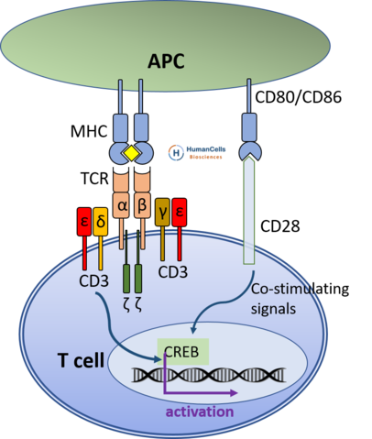

The MMR vaccine is a vaccine against measles, mumps, and rubella (German measles). The first dose is generally given to children around 9 to 15 months of age, with a second dose at 15 months to 6 years of age, with at least 4 weeks between the doses.

아데노신 디아 미나 아제 (adenosine deaminase, ADA)를 암호화하는 유전자의 돌연변이에서 유래한다. 이 효소가 없으면 ADP, GTP 및 dATP와

ADA deficiency is due to a lack of the enzymeadenosine deaminase. This deficiency results in an accumulation of deoxyadenosine,^{[6]} which, in turn, leads to:
- a buildup of dATP in all cells, which inhibits ribonucleotide reductase and prevents DNA synthesis, so cells are unable to divide. Since developing T cells and B cells are some of the most mitotically active cells, they are highly susceptible to this condition.
- an increase in S-adenosylhomocysteine since the enzyme adenosine deaminase is important in the purine salvage pathway; both substances are toxic to immature lymphocytes, which thus fail to mature.
Because T cells undergo proliferation and development in the thymus, affected individuals typically have a small, underdeveloped thymus.^{[7]} As a result, the immune system is severely compromised or completely lacking.
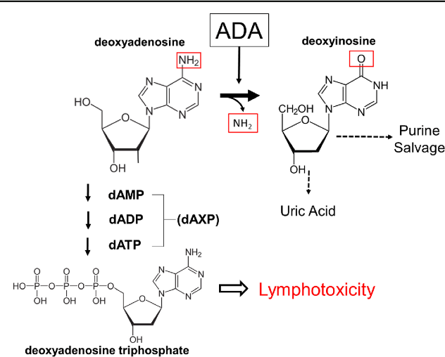

퓨린 뉴 클레오 시드 포스 포 릴라 제 (PNP)의 결핍으로 인해 dGTP가 축적되어 야기된다

Purine nucleoside phosphorylase deficiency, often called PNP-deficiency, is a rare autosomalrecessive ^{[1]} metabolic disorder which results in immunodeficiency.

The disorder is caused by a mutation of the purine nucleoside phosphorylase (PNP) gene, located at chromosome14q13.1.^{[3] [4]} This mutation was first identified by Eloise Giblett, a professor at the University of Washington, in 1975.^{[5]} PNP is a key enzyme in the purine catabolic^{[6]} pathway, and is required for purinedegradation. Specifically, it catalyzes the conversion of inosine to hypoxanthine and guanosine to guanine (both guanine and hypoxanthine will be made into xanthine which will then become uric acid). A deficiency of it leads to buildup of elevated deoxy-GTP (dGTP) levels resulting in T-cell toxicity and deficiency

이식편대숙주병 (GVHD)
Graft-versus-host disease (GvHD) is a medical complication following the receipt of transplanted tissue from a genetically different person. GvHD is commonly associated with stem cell transplants such as those that occur with bone marrow transplants. GvHD also applies to other forms of transplanted tissues such as solid organ transplants.
White blood cells of the donor's immune system which remain within the donated tissue (the graft) recognize the recipient (the host) as foreign (non-self). The white blood cells present within the transplanted tissue then attack the recipient's body's cells, which leads to GvHD. This should not be confused with a transplant rejection, which occurs when the immune system of the transplant recipient rejects the transplanted tissue; GvHD occurs when the donor's immune system's white blood cells reject the recipient.

전신성 홍 반성 루푸스 (SLE)
Systemic lupus erythematosus (SLE), also known simply as lupus, is an autoimmune disease in which the body's immune system mistakenly attacks healthy tissue in many parts of the body.^{[1]} Symptoms vary between people and may be mild to severe.^{[1]} Common symptoms include painful and swollen joints, fever, chest pain, hair loss, mouth ulcers, swollen lymph nodes, feeling tired, and a red rash which is most commonly on the face.^{[1]} Often there are periods of illness, called flares, and periods of remission during which there are few symptoms.^{[1]}

The cause of SLE is not clear.^{[1]} It is thought to involve genetics together with environmental factors.^{[4]} Among identical twins, if one is affected there is a 24% chance the other one will be as well.^{[1]}Female sex hormones, sunlight, smoking, vitamin D deficiency, and certain infections, are also believed to increase the ris

DiGeorge 비정상과 Wiskott Aldridge 증후군
DiGeorge syndrome, also known as 22q11.2 deletion syndrome, is a syndrome caused by the deletion of a small segment of chromosome 22.^{[7]} While the symptoms can vary, they often include congenital heart problems, specific facial features, frequent infections, developmental delay, learning problems and cleft palate.^{[7]} Associated conditions include kidney problems, hearing loss and autoimmune disorders such as rheumatoid arthritis or Graves disease

Wiskott–Aldrich syndrome (WAS) is a rare X-linked recessive disease characterized by eczema, thrombocytopenia (low platelet count), immune deficiency, and bloody diarrhea (secondary to the thrombocytopenia).^{[1]} It is also sometimes called the eczema-thrombocytopenia-immunodeficiency syndrome in keeping with Aldrich's original description in 1954.^{[2]} The WAS-related disorders of X-linked thrombocytopenia (XLT) and X-linked congenital neutropenia (XLN) may present similar but less severe symptoms and are caused by mutations of the same gene.

Chediak-Higashi 증후군

Chédiak–Higashi syndrome^{[1]} is a rare autosomal recessive disorder that arises from a mutation of a lysosomal trafficking regulator protein,^{[2]} which leads to a decrease in phagocytosis. The decrease in phagocytosis results in recurrent pyogenic infections, albinism and peripheral neuropathy.

Mutations in the CHS1 gene (also called LYST) have been found to be connected with Chédiak–Higashi Syndrome. This gene provides instructions for making a protein known as the lysosomal trafficking regulator. Researchers believe that this protein plays a role in the transport (trafficking) of materials into lysosomes. Lysosomes act as recycling centers within cells. They use digestive enzymes to break down toxic substances, digest bacteria that invade the cell, and recycle worn-out cell components. Although the lysosomal trafficking regulator protein is involved in the normal function of lysosomes, its exact role is unknown.

Aciclovir (ACV), also known as acyclovir, is an antiviral medication.^{[3]} It is primarily used for the treatment of herpes simplex virus infections, chickenpox, and shingles.^{[4]} Other uses include prevention of cytomegalovirus infections following transplant and severe complications of Epstein-Barr virus infection.^{[4] [5]} It can be taken by mouth, applied as a cream, or injected.^{[4]}
Common side effects include nausea and diarrhea.^{[4]} Potentially serious side effects include kidney problems and low platelets.^{[4]} Greater care is recommended in those with poor liver or kidney function.^{[4]} It is generally considered safe for use in pregnancy with no harm having been observed.^{[4] [6]} It appears to be safe during breastfeeding.^{[7] [8]}Aciclovir is a nucleoside analogue that is similar to guanosine.^{[4]} It works by decreasing the production of the virus's DNA.^{[4]}

Acyclovir, also called acycloguanosine, antiviral drug used to control the symptoms of infections involving herpes simplexvirus (HSV), which causes herpes simplex, or varicella-zoster virus (VZV; a type of herpesvirus), which causes shingles and chickenpox. Acyclovir was first discovered in the mid-1970s and is effective against active, replicating HSV or VZV.
Acyclovir belongs to a group of synthetic drugs called nucleoside analogs, which are characterized by their similarity to naturally occurring nucleosides—the structural subunits of DNA and RNA—that are found in cells and viruses. However, synthetic nucleoside analogs lack specific components of their natural counterparts and therefore—once incorporated into the genetic material of a cell or virus during replication—are unable to bind subsequent nucleosides, thereby terminating the synthesis of new strands of DNA or RNA.
Acyclovir, similar to all other nucleoside analogs, must be activated by addition of a phosphate group (phosphorylation) before it can inhibit the synthesis of viral DNA (HSV and VZV are DNA viruses). Acyclovir is phosphorylated by a viral enzyme called thymidine kinase (TK), to which the drug has a high affinity (attraction). Phosphorylation by either HSV-TK or VZV-TK converts acyclovir into acyclovir triphosphate, which is then incorporated into viral DNA, thereby blocking further DNA synthesis. Because acyclovir is attracted to a specific type of viral kinase, the drug enters and acts on only those cells infected with HSV or VZV. Thus, it is highly effective in disrupting the formation of herpesvirus DNA and has very little activity in uninfected cells, even at high concentrations. However, mutation of HSV-TK or VZV-TK can cause resistance to acyclovir.

NADPH 산화 효소
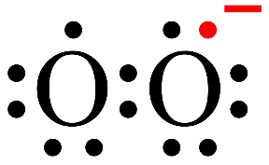
Phagocytes (i.e. neutrophils and macrophages) require an enzyme to produce reactive oxygen species to destroy bacteriaafter they are ingested (phagocytosis), a process known as the respiratory burst. This enzyme is termed "phagocyte NADPH oxidase" (PHOX). This enzyme oxidizes NADPH and reduces molecular oxygen to produce superoxide anions, a reactive oxygen species. Superoxide is then disproportionated into peroxide and molecular oxygen by superoxide dismutase. Finally, peroxide is used by myeloperoxidase to oxidize chloride ions into hypochlorite (the active component of bleach), which is toxic to bacteria. Thus, NADPH oxidase is critical for phagocyte killing of bacteria through reactive oxygen species.

nitroblue tetrazolium (NBT)
Nitroblue Tetrazolium
Nitroblue tetrazolium (NBT) undergoes reduction by O₂^{•−} to form diformazan, a dark blue insoluble precipitate.³¹ Similar to DHE, NBT detects intracellular O₂^{•−}

육아종(granuloma)은 여러 질병에서 나타나는 염증이다. 대식세포라는 백혈구가 덩어리진 것으로, 면역체계가 어떤 물질을 외래물질로 판단하여 제거하고자 하나 제거할 수 없을 때 발생한다.

Lymphadenopathy or adenopathy is disease of the lymph nodes, in which they are abnormal in size or consistency. Lymphadenopathy of an inflammatory type (the most common type) is lymphadenitis, producing swollen or enlarged lymph nodes.

Leukocyte extravasation, less commonly called diapedesis, is the movement of leukocytes out of the circulatory system and towards the site of tissue damage or infection. This process forms part of the innate immune response, involving the recruitment of non-specific leukocytes. Monocytes also use this process in the absence of infection or tissue damage during their development into macrophages.

In molecular biology, CD18 (Integrin beta chain-2) is an integrin beta chain protein that is encoded by the ITGB2gene in humans.^{[5]} Upon binding with one of a number of alpha chains, CD18 is capable of forming multiple heterodimers, which play significant roles in cellular adhesion and cell surface signaling, as well as important roles in immune responses.^{[5] [6]} CD18 also exists in soluble, ligand binding forms. Deficiencies in CD18 expression can lead to adhesion defects in circulating white blood cells in humans, reducing the immune system's ability to fight off foreign invaders.
The ITGB2 protein product is CD18. Integrins are integral cell-surface proteins composed of an alpha chain and a beta chain, and are crucial for cells to be able to efficiently bind to the extracellular matrix.^{[5]} This is especially important for neutrophils, as cellular adhesion plays a large role in extravasation from the blood vessels. A given chain may combine with multiple partners resulting in different integrins.
The known binding partners of CD18 are CD11a,^{[7]} CD11b,^{[8]} CD11c and CD11d.^{[5]} Binding of CD18 and CD11 results in the formation of Lymphocyte Functions Associated Antigen 1 (LFA-1),^{[7]} a protein found on B cells, all T cells, macrophages, neutrophils and NK cells. LFA-1 is involved in adhesion and binding to antigen presenting cells through interactions with the surface protein ICAM-1
Binding of CD18 and CD11b-d results in the formation of complement receptors (e.g. Macrophage-1 antigen receptor, Mac-1, when bound to CD11b),^{[8]} which are proteins found largely on neutrophils, macrophages and NK cells. These complement receptors participate in the innate immune response by recognizing foreign antigen peptides and phagocytizing them, thus destroying the antigen.

E 및 P 셀렉틴
Leukocyte extravasation occurs mainly in post-capillary venules, where haemodynamicshear forces are minimised. This process can be understood in several steps, outlined below as "chemoattraction", "rolling adhesion", "tight adhesion" and "(endothelial) transmigration". It has been demonstrated that leukocyte recruitment is halted whenever any of these steps is suppressed.
White blood cells (leukocytes) perform most of their functions in tissues. Functions include phagocytosis of foreign particles, production of antibodies, secretion of inflammatory response triggers (histamine and heparin), and neutralization of histamine. In general, leukocytes are involved in the defense of an organism and protect it from disease by promoting or inhibiting inflammatory responses. Leukocytes use the blood as a transport medium to reach the tissues of the body. Here is a brief summary of each of the four steps currently thought to be involved in leukocyte extravasation:
Chemoattraction[edit]
Upon recognition of and activation by pathogens, resident macrophages in the affected tissue release cytokines such as IL-1, TNFα and chemokines. IL-1, TNFα and C5a^{[1]} cause the endothelial cells of blood vessels near the site of infection to express cellular adhesion molecules, including selectins. Circulating leukocytes are localised towards the site of injury or infection due to the presence of chemokines.
Rolling adhesion[edit]
Like velcro, carbohydrate ligands on the circulating leukocytes bind to selectin molecules on the inner wall of the vessel, with marginal affinity. This causes the leukocytes to slow down and begin rolling along the inner surface of the vessel wall. During this rolling motion, transitory bonds are formed and broken between selectins and their ligands.
For example, the carbohydrate ligand for P-selectin, P-selectin glycoprotein ligand-1 (PSGL-1), is expressed by different types of leukocytes (white blood cells). The binding of PSGL-1 on the leukocyte to P-selectin on the endothelial cell allows for the leukocyte to roll along the endothelial surface. This interaction can be tuned by the glycosylation pattern of PSGL-1, such that certain glycovariants of PSGL-1 will have unique affinities for different selectins, allowing in some cases for cells to migrate to specific sites within the body (e.g. the skin).^{[2]}
Tight adhesion[edit]
At the same time, chemokines released by macrophages activate the rolling leukocytes and cause surface integrin molecules to switch from the default low-affinity state to a high-affinity state. This is assisted through juxtacrine activation of integrins by chemokines and soluble factors released by endothelial cells. In the activated state, integrins bind tightly to complementary receptors expressed on endothelial cells, with high affinity. This causes the immobilization of the leukocytes, which varies in vessels that contain different shear forces of the ongoing blood flow.
Transmigration[edit]
The cytoskeletons of the leukocytes are reorganised in such a way that the leukocytes are spread out over the endothelial cells. In this form, leukocytes extend pseudopodia and pass through gaps between endothelial cells. Transmigration of the leukocyte occurs as PECAM proteins, found on the leukocyte and endothelial cell surfaces, interact and effectively pull the cell through the endothelium. Once through the endothelium, the leukocyte must penetrate the basement membrane. The mechanism for penetration is disputed, but may involve proteolytic digestion of the membrane, mechanical force, or both.^{[3]} The entire process of blood vessel escape is known as diapedesis. Once in the interstitial fluid, leukocytes migrate along a chemotactic gradient towards the site of injury or infection.
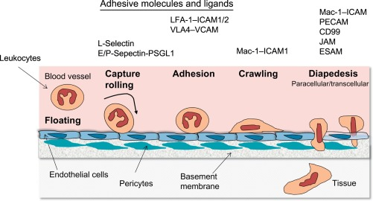

C1 억제제 (C1INH)와 같은 보체의 조절되지 않은 활성화를 막거나 DAF (Decay Accelerating Factor)와 같은 무해한 방관자 세포의 손상을 방지하는 수많은 조절 분자가 있습니다.

C1-inhibitor (C1-inh, C1 esterase inhibitor) is a protease inhibitor belonging to the serpin superfamily. Its main function is the inhibition of the complement system to prevent spontaneous activation

Complement decay-accelerating factor, also known as CD55 or DAF, is a protein that, in humans, is encoded by the CD55gene.^{[5]}
DAF regulates the complement system on the cell surface. It recognizes C4b and C3b fragments that are created during activation of C4 (classical or lectin pathway) or C3 (alternative pathway). Interaction of DAF with cell-associated C4b of the classical and lectin pathways interferes with the conversion of C2 to C2b, thereby preventing formation of the C4b2b C3-convertase, and interaction of DAF with C3b of the alternative pathway interferes with the conversion of factor B to Bb by factor D, thereby preventing formation of the C3bBb C3 convertase of the alternative pathway. Thus, by limiting the amplification convertases of the complement cascade, DAF indirectly blocks the formation of the membrane attack complex.
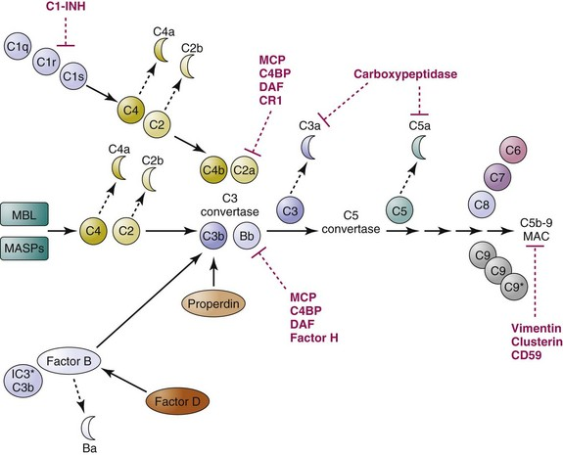

CH50 및 AP50 테스트
Total complement activity is a test performed to assess the level of functioning of the complement system
The terms "CH50"^{[1]} or "CH100" may refer to this test. The test is based on the capacity of a serum to lyse sheep erythrocytes coated with anti-sheep antibodies (preferably rabbit IgG).
In combination with the Alternative pathway hemolytic assay ("AH50") it can indicate terminal pathway deficiencies (C3, C5-C9; absence of hemolysis in both CH50 and AH50), classic pathway deficiencies (C1, C2, C4; absence of lysis in CH50) and alternative pathway deficiencies (Factor I, B, H, D, properdin; absence of lysis in AH50).
Increased CH50 values may be seen in cancer or ulcerative colitis. Decreased CH50 values may be seen in cirrhosis or hepatitis ^{[2]} or Systemic lupus erythematosus.

In the test the reciprocal of the plasma volume needed to destroy 50% of available rabbit erythrocytes is defined as the functional measure of this activity (AP50)

Hereditary angioedema (HAE) is a disorder that results in recurrent attacks of severe swelling.^{[3]} The swelling most commonly affects the arms, legs, face, intestinal tract, and airway.^{[3]} Itchiness does not typically occur.^{[2]} If the intestinal tract is affected abdominal pain and vomiting may occur.^{[1]} Swelling of the airway can result in its obstruction.^{[1]} Attacks, without treatment, typically occur every couple of weeks and last for a few days.^{[3]}
There are three main types of HAE.^{[3]} Type I and II are caused by a mutation in the SERPING1 gene that makes the C1 inhibitor protein while type III is often due to a mutation of the factor XII gene.^{[3]} This results in increased amounts of bradykinin which promotes swelling.^{[3]} The condition may be inherited from a person's parents in an autosomal dominant manner or occur as a new mutation.^{[3]} Triggers of an attack may include minor trauma or stress, but often occurs without any obvious preceding event.^{[3]} Diagnosis of type I and II is based upon measuring C4 and C1-inhibitor levels.

Myxedema is a term used synonymously with severe hypothyroidism. However, the term is also used to describe a dermatological change that can occur in hypothyroidism and some forms of hyperthyroidism. In this later sense, myxedema refers to deposition of mucopolysaccharides in the dermis, which results in swelling of the affected area. One manifestation of myxedema occurring in the lower limb is pretibial myxedema, a hallmark of Graves disease, an autoimmune form of hyperthyroidism. Myxedema can also occur in Hashimoto's thyroiditis and other long-standing forms of hypothyroidism.

Thyroglobulin (Tg) is a 660 kDa, dimericprotein produced by the follicular cells of the thyroid and used entirely within the thyroid gland. Thyroglobulin protein accounts for approximately half of the protein content of the thyroid gland.^{[5]} Human TG (HTG) is a homodimer of subunits each containing 2768 amino acids as synthesized (a short signal peptide may be removed from the N-terminus in the mature protein).^{[6]}
The protein is a precursor of the thyroid hormones; these are produced when thyroglobulin's tyrosineresidues are combined with iodine and the protein is subsequently cleaved. Each thyroglobulin molecule contains approximately 100-120 tyrosine residues, but only a small number (20) of these are subject to iodination by thyroperoxidase in the follicular colloid. Therefore, each Tg molecule forms only approximately 10 thyroid hormone molecules

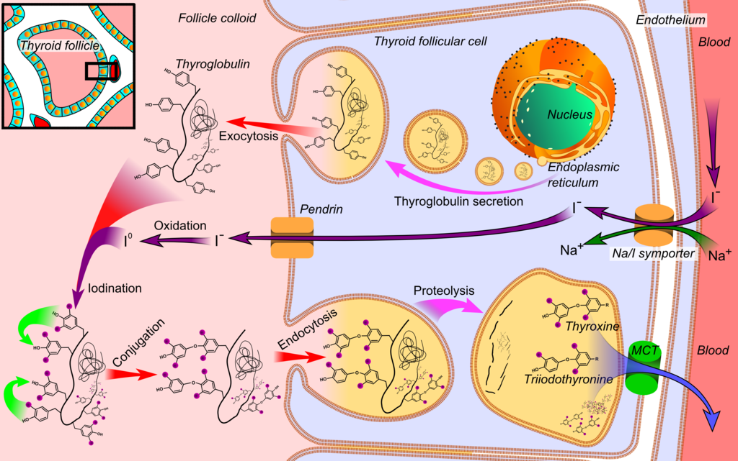

Thyroid peroxidase, also called thyroperoxidase (TPO) or iodide peroxidase, is an enzyme expressed mainly in the thyroid where it is secreted into colloid. Thyroid peroxidase oxidizes iodide ions to form iodine atoms for addition onto tyrosine residues on thyroglobulin for the production of thyroxine (T₄) or triiodothyronine (T₃), the thyroid hormones.^{[1]} In humans, thyroperoxidase is encoded by the TPOgene

Inorganic iodine enters the body primarily as iodide, I⁻. After entering the thyroid follicle (or thyroid follicular cell) via a Na⁺/I⁻ symporter (NIS) on the basolateral side, iodide is shuttled across the apical membrane into the colloid via pendrin, after which thyroid peroxidase oxidizes iodide to atomic iodine (I) or iodinium (I⁺). The "organification of iodine," the incorporation of iodine into thyroglobulin for the production of thyroid hormone, is nonspecific; that is, there is no TPO-bound intermediate, but iodination occurs via reactive iodine species released from TPO.^{[4]} The chemical reactions catalyzed by thyroid peroxidase occur on the outer apical membrane surface and are mediated by hydrogen peroxide.

