제4장 강의메모

acute phase response a group of physiologic processes occurring soon after the onset of infection, trauma, inflammatory processes, and some malignant conditions. The most prominent change is a dramatic increase of acute phase proteins in the serum, especially C-reactive protein.

Kaposi's sarcoma (KS) is a type of cancer that can form masses in the skin, lymph nodes, or other organs.[4] The skin lesions are usually purple in color.[4] They can occur singularly, in a limited area, or be widespread.[7] It may worsen either gradually or quickly.[6] Lesions may be flat or raised.[6] Human herpesvirus 8 (HHV8) is found in the lesions of all those who are affected.[4] Risk factors include poor immune function, either as a result of disease or specific medications, and chronic lymphedema.

Hairy cell leukemia is a rare, slow-growing cancer of the blood in which your bone marrow makes too many B cells (lymphocytes), a type of white blood cell that fights infection.
These excess B cells are abnormal and look "hairy" under a microscope. As the number of leukemia cells increases, fewer healthy white blood cells, red blood cells and platelets are produced

Granulocytes are a category of white blood cells characterized by the presence of granules in their cytoplasm.[1] They are also called polymorphonuclear leukocytes or polymorphonuclear neutrophils (PMN, PML, or PMNL) because of the varying shapes of the nucleus, which is usually lobed into three segments. This distinguishes them from the mononuclear agranulocytes. In common parlance, the term polymorphonuclear leukocyte often refers specifically to "neutrophil granulocytes",[2] the most abundant of the granulocytes; the other types (eosinophils, basophils, and mast cells) have lower numbers. Granulocytes are produced via granulopoiesis in the bone marrow.

Examples of toxic materials produced or released by degranulation by granulocytes on the ingestion of microorganisms are:

Antimicrobial agents (Defensins and Eosinophil cationic protein)
Enzymes
Acid hydrolases: further digest bacteria
Lysozyme: dissolves cell walls of some gram-positive bacteria
Low pH vesicles (3.5-4.0)
Toxic nitrogen oxides (nitric oxide)
Toxic oxygen-derived products (e.g., superoxide, hydrogen peroxide, hydroxy radicals, singlet oxygen, hypohalite)

Agranulocytes or nongranulocytes, also mononuclear leukocytes, are one of the two types of white blood cells, also known as leukocytes. The other type of white blood cells are known as granulocytes. Agranular cells are noted by the absence of granules in their cytoplasm, which distinguishes them from granulocytes. The two types of agranulocytes in the blood circulation are lymphocytes and monocytes, and these make up about 35% of the hematologic blood values[1]. A third type of agranulocyte, the macrophage, is formed in the tissue when monocytes leave the circulation and differentiate into macrophages.
Interferons (IFNs) are a group of signaling proteins ^{[1]} made and released by host cells in response to the presence of several viruses. In a typical scenario, a virus-infected cell will release interferons causing nearby cells to heighten their anti-viral defenses.
IFNs belong to the large class of proteins known as cytokines, molecules used for communication between cells to trigger the protective defenses of the immune system that help eradicate pathogens.^{[2]} Interferons are named for their ability to "interfere" with viral replication ^{[2]} by protecting cells from virus infections. IFNs also have various other functions: they activate immune cells, such as natural killer cells and macrophages; they increase host defenses by up-regulating antigen presentation by virtue of increasing the expression of major histocompatibility complex (MHC) antigens. Certain symptoms of infections, such as fever, muscle pain and "flu-like symptoms", are also caused by the production of IFNs and other cytokines.
More than twenty distinct IFN genes and proteins have been identified in animals, including humans. They are typically divided among three classes: Type I IFN, Type II IFN, and Type III IFN. IFNs belonging to all three classes are important for fighting viral infections and for the regulation of the immune system.

Hairy cell leukemia is a rare, slow-growing cancer of the blood in which your bone marrow makes too many B cells (lymphocytes), a type of white bloodcell that fights infection. These excess B cells are abnormal and look "hairy" under a microscope

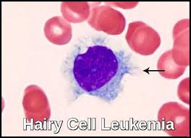

C-reactive protein (CRP) is a blood test marker for inflammation in the body. CRP is produced in the liver and its level is measured by testing the blood. CRP is classified as an acute phase reactant, which means that its levels will rise in response to inflammation

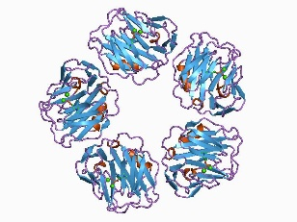

C-reactive protein (CRP) is an annular (ring-shaped), pentameric protein found in blood plasma, whose levels rise in response to inflammation. It is an acute-phase protein of hepatic origin that increases following interleukin-6 secretion by macrophages and T cells. Its physiological role is to bind to lysophosphatidylcholine expressed on the surface of dead or dying cells (and some types of bacteria) in order to activate the complement system via C1q.^{[5]}

Function[edit]
CRP binds to the phosphocholine expressed on the surface of dead or dying cells and some bacteria. This activates the complement system, promoting phagocytosis by macrophages, which clears necrotic and apoptotic cells and bacteria.^{[13]}
This so-called acute phase response occurs as a result of a rise in the concentration of IL-6, which is produced by macrophages ^{[6]} as well as adipocytes ^{[7]} in response to a wide range of acute and chronic inflammatory conditions such as bacterial, viral, or fungal infections; rheumatic and other inflammatory diseases; malignancy; and tissue injury and necrosis. These conditions cause release of interleukin-6 and other cytokines that trigger the synthesis of CRP and fibrinogen by the liver.
CRP binds to phosphocholine on micro-organisms. It is thought to assist in complement binding to foreign and damaged cells and enhances phagocytosis by macrophages (opsonin-mediated phagocytosis), which express a receptor for CRP. It plays a role in innate immunity as an early defense system against infections.^{[1}

Mannose-binding lectin (MBL), also called mannan-binding lectin or mannan-binding protein (MBP), is a lectin that is instrumental in innate immunity ^{[5] [6]} as an opsonin and via the lectin pathway.
MBL has an oligomeric structure (400-700 kDa), built of subunits that contain three presumably identical peptide chains of about 30 kDa each.
Although MBL can form several oligomeric forms, there are indications that dimers and trimers are biologically active as an opsonin and at least a tetramer form is needed for activation of complement

An opsonin (from the Greek opsōneîn, to prepare for eating) is any molecule that enhances phagocytosis by marking an antigen for an immune response or marking dead cells for recycling (i.e., causes the phagocyte to "relish" the marked cell).^{[1]}

Opsonization (also, opsonisation) is the molecular mechanism whereby molecules, microbes, or apoptotic cells are chemically modified to have stronger interactions with – to be more "delicious" to – cell surface receptors on phagocytes and NK cells. With the antigen coated in opsonins, binding to immune cells is greatly enhanced. Opsonization also mediates phagocytosis via signal cascades from cell surface receptors.^{[2]}

The antigen-binding (Fab) fragment is a region on an antibody that binds to antigens. It is composed of one constant and one variable domain of each of the heavy and the light chain.

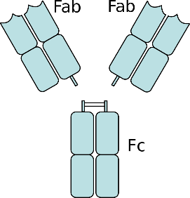

An antibody digested by papain yields three fragments: two Fab fragments and one Fc fragment
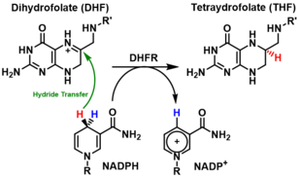

Hybridoma cells are selected using HAT (Hypoxanthine Aminopterin Thymidine) medium.
HAT selection depends on the fact that mammalian cells can synthesize nucleotides by two different pathways: the de novo and the salvage pathways. Aminopterin (a folic acid analog) blocks the de novo pathway, while hypoxanthine and thymidine allow growth via the salvage pathway.
Indeed, the DNA de novo synthesis (in which a methyl or formyl group is transferred from an activated from of tetrahydrofolate) is blocked by Aminopterin. When the de novo pathway is blocked, cells utilize the salvage pathway, which bypasses the aminopterin block by converting purines and pyrimidines directly into DNA. The enzymes catalyzing the salvage pathway include hypoxanthine-guanine phosphorribosyl transferase (HGPRT) and thymidine kinase (TK). This pathway can convert hypoxanthine in IMP, a reaction catalysed by HGPRT. It can also convert thymidine in dTMP, a reaction catalysed by TK.
On this medium, only cells which have functionnal HGPRT and TK will grow via the salvage pathway.
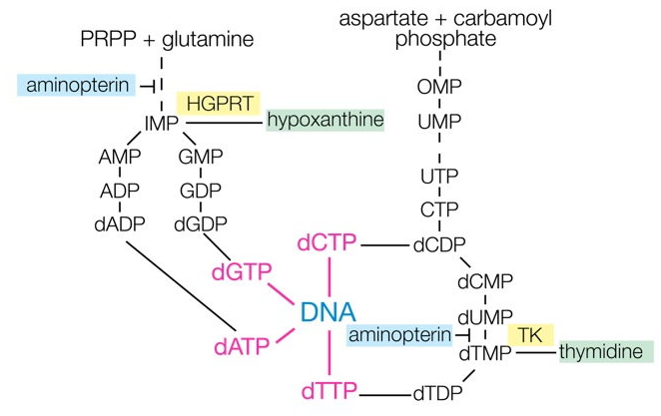
Figure: Principle of HAT selection (origin: http://nfs.unipv.it/nfs/minf/dispense/immunology/lectures/files/monoclonal_antibodies.html)

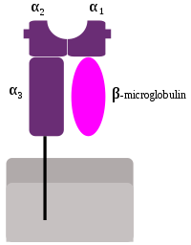
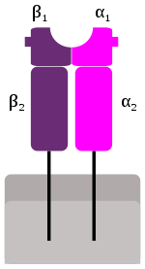

Most mammals have MHC variants similar to those of humans, who bear great allelic diversity, especially among the nine classical genes—seemingly due largely to gene duplication—though human MHC regions have many pseudogenes. The most diverse loci, namely HLA-A, HLA-B, and HLA-DRB1, have roughly 1000, 1600, and 870 known alleles, respectively[citation needed].[26] Many HLA alleles are ancient, sometimes of closer homology to a chimpanzee MHC alleles than to some other human alleles of the same gene.

Granzymes are serine proteases released by cytoplasmic granules within cytotoxic T cells and natural killer (NK) cells. They induce programmed cell death (apoptosis) in the target cell, thus eliminating cells that have become cancerous or are infected with viruses or bacteria.[1] Granzymes also kill bacteria[2] and inhibit viral replication. In NK cells and T cells, granzymes are packaged in cytotoxic granules with perforin.

