제3장 강의 메모
3.2 피부감염
피부: 선천적 방어벽
바이러스
인간 유두종 바이러스: 사마귀
헤르페스 바이러스: 구순포진, 생식기포진, 수두(대상포진)

세균
Propionibacterium
S. aureus
S. pyogenes
Mycobacterium leprae

3.3 눈 귀 중추신경 감염
S. aureus: 눈다래끼
C. trachomatis: 트라코마, 결막염

이하선염
Mumpsis aviral diseasecaused by themumps virus.[2]
Initial signs and symptoms often includefever,muscle pain,headache, poor appetite, andfeeling generally unwell.[1]
[6]
This is then usually followed bypainful swelling of one or both parotid salivary glands.[4]
[6]
Symptoms typically occur 16 to 18 days after exposure and resolve after seven to ten days.[1]
[2]
Symptoms are often more severe in adults than in children.[1]
About a third of people have mild or no symptoms.[1]
Complications may includemeningitis(15 percent),pancreatitis(four percent),inflammation of the heart, permanentdeafness, andtesticular inflammationwhich uncommonly results ininfertility.[1]
[6]
Women may developovarian swellingbut this does not increase the risk of infertility

Mumps virus belongs to the genusRubulavirusin the familyParamyxoviridaeand produces roughly spherical, enveloped virions of about 200 nm in diameter.[2]
The mumps virus genome is a linear, single-stranded molecule of negative-senseRNAand 15,384 nucleotides in length

중추신경계
An ECHO (enteric cytopathic human orphan ) virus is a type of RNA virus that belongs to the species Enterovirus B , genus Enterovirus of the Picornaviridae family.^{[1]} Echoviruses are found in the gastrointestinal tract (hence it being part of the enterovirus genus) and exposure to the virus causes other opportunistic infections and diseases, notably aseptic meningitis .^{[2]}

Coxsackievirus is a virus that belongs to a family of nonenveloped , linear, positive-sense single-stranded RNA viruses , Picornaviridae and the genus Enterovirus , which also includes poliovirus and echovirus . Enteroviruses are among the most common and important human pathogens, and ordinarily its members are transmitted by the fecal-oral route. Coxsackieviruses share many characteristics with poliovirus. With control of poliovirus infections in much of the world, more attention has been focused on understanding the nonpolio enteroviruses such as coxsackievirus.
Coxsackieviruses are among the leading causes of aseptic meningitis(the other usual suspects being echovirus and mumps virus).
The entry of coxsackievirus into cells, especially endothelial cells, is mediated by Coxsackie virus and adenovirus receptor.

Poliovirus, the causative agent of poliomyelitis (commonly known as polio), is a member virus of Enterovirus C, in the family of Picornaviridae.^{[1]}
Poliovirus is composed of an RNA genome and a protein capsid. The genome is a single-stranded positive-sense RNA genome that is about 7500 nucleotides long.^{[2]} The viral particle is about 30 nm in diameter with icosahedral symmetry. Because of its short genome and its simple composition—only RNA and a nonenveloped icosahedral protein coat that encapsulates it, poliovirus is widely regarded as the simplest significant virus.^{[3]}

Togaviridae is a family of viruses . Humans, mammals, birds, and mosquitoes serve as natural hosts. There are currently 32 species in this family, divided among 2 genera. Diseases associated with this family include: Alphaviruses: arthritis, encephalitis; Rubiviruses: rubella
The Togaviridae family belong to group IV of the Baltimore classification of viruses. The genome is linear, non-segmented, single-stranded, positive sense RNA that is 10,000–12,000 nucleotides long

호흡기 감염
Defensins are small cysteine -rich cationic proteins found in both vertebrates and invertebrates . They have also been reported in plants.^{[1] [2]} They are, and function as, host defense peptides . They are active against bacteria , fungi and many enveloped and nonenveloped viruses . They consist of 18-45 amino acids including six (in vertebrates) to eight conserved cysteine residues. Cells of the immune system contain these peptides to assist in killing phagocytosed bacteria, for example in neutrophil granulocytes and almost all epithelial cells . Most defensins function by binding to the microbial cell membrane , and, once embedded, forming pore-like membrane defects that allow efflux of essential ions and nutrients.

Lactoferrin (LF), also known as lactotransferrin (LTF), is a multifunctional protein of the transferrin family. Lactoferrin is a globular glycoprotein with a molecular mass of about 80 kDa that is widely represented in various secretory fluids, such as milk, saliva, tears, and nasal secretions. Lactoferrin is also present in secondary granules of PMNs and is secreted by some acinar cells. Lactoferrin can be purified from milk or produced recombinantly. Human colostrum ("first milk") has the highest concentration, followed by human milk, then cow milk (150 mg/L).^{[5]}
Lactoferrin is one of the components of the immune system of the body; it has antimicrobial activity (bacteriocide, fungicide) and is part of the innate defense, mainly at mucoses.^{[5]} In particular, lactoferrin provides antibacterial activity to human infants.^{[6] [7]} Lactoferrin interacts with DNA and RNA, polysaccharides and heparin, and shows some of its biological functions in complexes with these ligands.

위장 감염
입: 진균가염, 아구창(칸디다) 방선균증, 치석(S.sanguis, mutans)

Giardia lamblia: 편모충
크립토스포리듐: 작은 포자충

Peyer's patches (or aggregated lymphoid nodules , or occasionally PP for brevity) are organized lymphoid follicles , named after the 17th-century Swiss anatomist Johann Conrad Peyer . They are an important part of gut associated lymphoid tissue usually found in humans in the lowest portion of the small intestine , mainly in the distal jejunum and the ileum , but also could be detected in the duodenum .^{[1]}

Campylobacter jejuni (see image below) is usually the most common cause of community-acquired inflammatory enteritis. In developing regions, the diarrhea may be watery.

Lymphogranuloma venereum (LGV) (also known as "Climatic bubo",^{[1]} "Durand–Nicolas–Favre disease",^{[1]}"Poradenitis inguinale", ^{[1]}, "Lymphogranuloma inguinale" and "Strumous bubo"^{[1]}) is a sexually transmitted disease caused by the invasive serovars L1, L2, L2a or L3 of Chlamydia trachomatis.^{[2]}
LGV is primarily an infection of lymphatics and lymph nodes. Chlamydia trachomatis is the bacteria responsible for LGV. It gains entrance through breaks in the skin, or it can cross the epithelial cell layer of mucous membranes. The organism travels from the site of inoculation down the lymphatic channels to multiply within mononuclear phagocytes of the lymph nodes it passes.

Primary stage[edit]
LGV may begin as a self-limited painless genital ulcer that occurs at the contact site 3–12 days after infection. Women rarely notice a primary infection because the initial ulceration where the organism penetrates the mucosal layer is often located out of sight, in the vaginal wall. In men fewer than 1/3 of those infected notice the first signs of LGV. This primary stage heals in a few days. Erythema nodosum occurs in 10% of cases.
Secondary stage[edit]
The secondary stage most often occurs 10–30 days later, but can present up to six months later. The infection spreads to the lymph nodes through lymphatic drainage pathways. The most frequent presenting clinical manifestation of LGV among males whose primary exposure was genital is unilateral (in 2/3 of cases) lymphadenitis and lymphangitis, often with tender inguinal and/or femoral lymphadenopathy because of the drainage pathway for their likely infected areas. Lymphangitis of the dorsal penis may also occur and resembles a string or cord. If the route was anal sex the infected person may experience lymphadenitis and lymphangitis noted above. They may instead develop proctitis, inflammation limited to the rectum (the distal 10–12 cm) that may be associated with anorectal pain, tenesmus, and rectal discharge, or proctocolitis, inflammation of the colonic mucosa extending to 12 cm above the anus and associated with symptoms of proctitis plus diarrhea or abdominal cramps.
In addition, symptoms may include inflammatory involvement of the perirectal or perianal lymphatic tissues. In females, cervicitis, perimetritis, or salpingitis may occur as well as lymphangitis and lymphadenitis in deeper nodes. Because of lymphatic drainage pathways, some patients develop an abdominal mass which seldom suppurates, and 20–30% develop inguinal lymphadenopathy. Systemic signs which can appear include fever, decreased appetite, and malaise. Diagnosis is more difficult in women and men who have sex with men (MSM) who may not have the inguinal symptoms.
Over the course of the disease, lymph nodes enlarge, as may occur in any infection of the same areas as well. Enlarged nodes are called buboes. Buboes are commonly painful. Nodes commonly become inflamed, thinning and fixation of the overlying skin. These changes may progress to necrosis, fluctuant and suppurative lymph nodes, abscesses, fistulas, strictures, and sinus tracts. During the infection and when it subsides and healing takes place, fibrosis may occur. This can result in varying degrees of lymphatic obstruction, chronic edema, and strictures. These late stages characterised by fibrosis and edema are also known as the third stage of LGV and are mainly permanent.

A chancre (/ˈʃæŋkər/SHANG-kər)^{[1]} is a painless genital ulcer most commonly formed during the primary stage of syphilis. This infectious lesion forms approximately 21 days after the initial exposure to Treponema pallidum, the gram-negative spirochaete bacterium yielding syphilis

A gumma is a soft, non-cancerous growth resulting from the tertiary stage of syphilis. It is a form of granuloma.

Sabouraud agar or Sabouraud Dextrose Agar or SDA is a type of agar growth medium containing peptones.^{[1]} It is used to cultivate dermatophytes and other types of fungi, and can also grow filamentous bacteria such as Nocardia.^{[2] [3] [4]} It has utility for research and clinical care.

Norovirus, sometimes referred to as the winter vomiting bug, is the most common cause of gastroenteritis. Infection is characterized by diarrhea, vomiting, and stomach pain. Blood is not usually present. Fever or headaches may also occur. This usually develops 12 to 48 hours after being exposed. Recovery typically occurs within 1 to 3 days. Complications may include dehydration.

Conjugate vaccines combine a weak antigen with a strong antigen so that the immune system has a stronger response to the weak antigen.
Vaccines are used to prevent diseases by invoking an immune response to an antigen, the foreign part of a bacteria or virus that the immune system recognizes. This is usually accomplished with an attenuated or dead version of a pathogenic bacterium or virus in the vaccine, so that the immune system can recognize the antigen later in life. Many vaccines contain a single antigen that the body will recognize.
However, the antigen of some pathogenic bacteria does not elicit a strong response from the immune system, so a vaccination against this weak antigen would not protect the person later in life. In this case, a conjugate vaccine is used in order to invoke an immune system response against the weak antigen. In a conjugate vaccine, the weak antigen is covalently attached to a strong antigen, thereby eliciting a stronger immunological response to the weak antigen. Most commonly, the weak antigen is a polysaccharide that is attached to strong protein antigen. However, peptide/protein and protein/protein conjugates have also been developed

A toxoid is an inactivated toxin (usually an exotoxin) whose toxicity has been suppressed either by chemical (formalin) or heat treatment, while other properties, typically immunogenicity, are maintained. Toxins are secreted by bacteria, whereas toxoids are altered form of toxins;

항생제작용 기작 4가지

Aminoglycoside is a medicinal and bacteriologic category of traditional Gram-negativeantibacterial medications that inhibit protein synthesis and contain as a portion of the molecule an amino-modified glycoside (sugar). The term can also refer more generally to any organic molecule that contains amino sugar substructures. Aminoglycoside antibiotics display bactericidal activity against Gram-negative aerobes and some anaerobic bacilli where resistance has not yet arisen but generally not against Gram-positive and anaerobic Gram-negative bacteria.
Streptomycin is the first-in-class aminoglycoside antibiotic. It is derived from Streptomyces griseus and is the earliest modern agent used against tuberculosis. Streptomycin lacks the common 2-deoxystreptamine moiety (image right, below) present in most other members of this class. Other examples of aminoglycosides include the deoxystreptamine-containing agents kanamycin, tobramycin, gentamicin, and neomycin

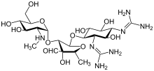

스트렙토마이신

Lincosamides consist of pyrrolidine ring linked to a pyranose moiety (methylthio-lincosamide) via an amide bond. Hydrolysis of lincosamides, specifically lincomycin, splits the molecule into its building blocks of the sugar and proline moieties. Both of these derivatives can conversely be recombined into the drug itself or a derivative.

erythromycin

The macrolides are a class of natural products that consist of a large macrocycliclactone ring to which one or more deoxy sugars, usually cladinose and desosamine, may be attached. The lactone rings are usually 14-, 15-, or 16-membered. Macrolides belong to the polyketide class of natural products. Some macrolides have antibiotic or antifungal activity and are used as pharmaceutical drugs

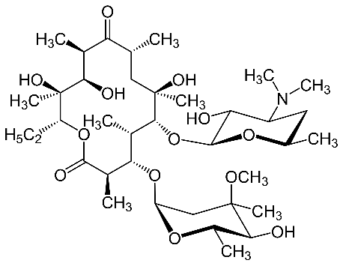

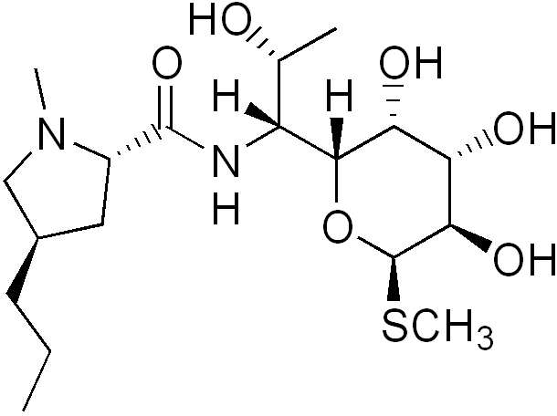

^{링코마이신}

Tetracyclines are a group of broad-spectrum antibiotic compounds that have a common basic structure and are either isolated directly from several species of Streptomycesbacteria or produced semi-synthetically from those isolated compounds. Tetracycline molecules comprise a linear fused tetracyclic nucleus (rings designated A, B, C and D) to which a variety of functional groups are attached. Tetracyclines are named for their four ("tetra-") hydrocarbon rings ("-cycl-") derivation ("-ine"). They are defined as a subclass of polyketides, having an octahydrotetracene-2-carboxamide skeleton and are known as derivatives of polycyclic naphthacene carboxamide. While all tetracyclines have a common structure, they differ from each other by the presence of chloride, methyl, and hydroxyl groups. These modifications do not change their broad antibacterial activity, but do affect pharmacological properties such as half-life and binding to proteins in serum.

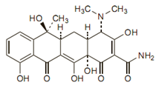
^{테트라사이클린}

^{beta-lactam계 항생제}
Penicillin-binding proteins (PBPs) are a group of proteins that are characterized by their affinity for and binding of penicillin. They are a normal constituent of many bacteria; the name just reflects the way by which the protein was discovered. All β-lactam antibiotics (except for tabtoxinine-β-lactam, which inhibits glutamine synthetase) bind to PBPs, which are essential for bacterial cell wall synthesis. PBPs are members of a subgroup of enzymes called transpeptidases. Specifically, PBPs are DD-transpeptidases(D-alanyl-D-alaninecarboxypeptidase)

^{항생제내성}

^{penicillin 내성}
Beta-lactamases are enzymes (EC 3.5.2.6) produced by bacteria that provide multi-resistance to β-lactam antibiotics such as penicillins, cephalosporins, cephamycins, and carbapenems (ertapenem), although carbapenems are relatively resistant to beta-lactamase. Beta-lactamase provides antibiotic resistance by breaking the antibiotics' structure. These antibiotics all have a common element in their molecular structure: a four-atom ring known as a β-lactam. Through hydrolysis, the enzyme lactamase breaks the β-lactam ring open, deactivating the molecule's antibacterial properties.

There are three mechanisms of aminoglycoside resistance: reduced uptake or decreased cell permeability, alterations at the ribosomal binding sites, or production of aminoglycoside modifying enzymes.

Reduced uptake or decreased cell permeability

Some strains of Pseudomonas aeruginosa and other gram-negative bacilli exhibit aminoglycoside resistance due to a transport defect or membrane impermeabilization. This mechanism is likely chromosomally mediated and results in cross-reactivity to all aminoglycosides. The level of resistance that is seen is moderate (i.e. intermediate susceptibility).1

^{Altered Ribosome Binding Sites}

Mutations at the site of aminoglycoside attachment may interfere with ribosomal binding. Resistance to streptomycin can occur by this mechanism since this agent binds to a single site on the 30S subunit of the ribosome. Resistance to the other aminoglycosides by this mechanism is uncommon since they bind to multiple sites on both ribosomal subunits and high-level resistance cannot be selected by a single step.

^{Enzymatic Modification}

Enzymatic modification is the most common type of aminoglycoside resistance. Over 50 different enzymes have been identified. Enzymatic modification results in high-level resistance. The genes encoding for aminoglycoside modifying enzymes are usually found on plasmids and transposons. Most enzyme-mediated resistance in gram-negative bacilli is due to multiple genes. It is hypothesized that the enzymes are derived from organisms that make the aminoglycoside or from the mutation of genes that encode the enzymes involved in cellular respiration.

There are three types of aminoglycoside modifying enzymes:

1. N-Acetyltransferases (AAC) – catalyzes acetyl CoA-dependent acetylation of an amino group

2. O-Adenyltransferases (ANT) – catalyzes ATP-dependent adenylation of hydroxyl group

3. O-Phosphotransferases (APH) – catalyzes ATP-dependent phosphorylation of a hydroxyl group

The tetracycline resistance protein Tet(A) is a tetracycline efflux protein that functions as a metal-tetracycline/H+ antiporter This is an energy-dependent process that decreases the accumulation of the antibiotic in whole cells. Tet(A) is encoded by the transposon Tn10, and is an integral membrane protein with twelve potential transmembrane domains

^{세균의 세포벽}
Peptidoglycan, also known as murein, is a polymer consisting of sugars and amino acids that forms a mesh-like layer outside the plasma membrane of most bacteria, forming the cell wall. The sugar component consists of alternating residues of β-(1,4) linked N-acetylglucosamine (NAG) and N-acetylmuramic acid (NAM). Attached to the N-acetylmuramic acid is a peptide chain of three to five amino acids. The peptide chain can be cross-linked to the peptide chain of another strand forming the 3D mesh-like layer.[1] Peptidoglycan serves a structural role in the bacterial cell wall, giving structural strength, as well as counteracting the osmotic pressure of the cytoplasm. Peptidoglycan is also involved in binary fission during bacterial cell reproduction.

The peptidoglycan layer is substantially thicker in Gram-positive bacteria (20 to 80 nanometers) than in Gram-negative bacteria (7 to 8 nanometers).

The peptidoglycan layer in the bacterial cell wall is a crystal lattice structure formed from linear chains of two alternating amino sugars, namely N-acetylglucosamine (GlcNAc or NAGA) and N-acetylmuramic acid (MurNAc or NAMA). The alternating sugars are connected by a β-(1,4)-glycosidic bond. Each MurNAc is attached to a short (4- to 5-residue) amino acid chain, containing L-alanine, D-glutamic acid, meso-diaminopimelic acid, and D-alanine in the case of Escherichia coli (a Gram-negative bacterium) or L-alanine, D-glutamine, L-lysine, and D-alanine with a 5-glycine interbridge between tetrapeptides in the case of Staphylococcus aureus (a Gram-positive bacterium). Peptidoglycan is one of the most important sources of D-amino acids in nature.

Cross-linking between amino acids in different linear amino sugar chains occurs with the help of the enzyme DD-transpeptidase and results in a 3-dimensional structure that is strong and rigid. The specific amino acid sequence and molecular structure vary with the bacterial species.

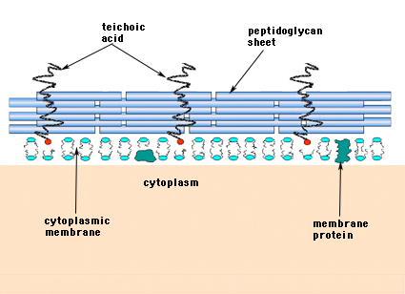

^{G+}
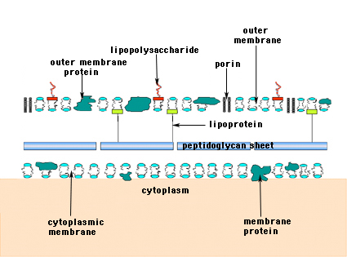

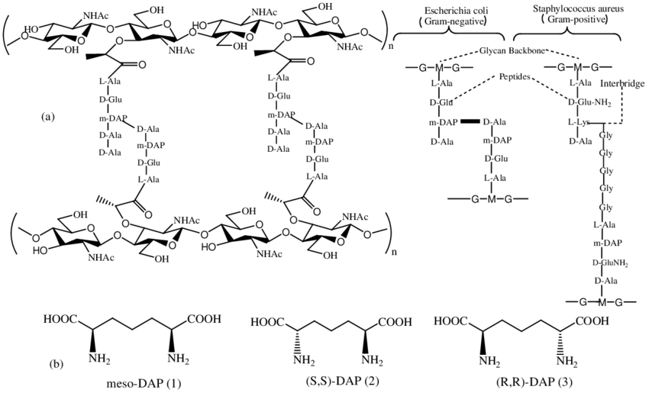
^{G-}

