2.1 서론

병원체:
opportunlsdc pathogen
병의발생(발병):

병원성: 감염량, 병의 강도
zoonoses 인축공통전염병
carriers
2.2 병원체 분류

프리온
-Spongiform encephalopathies 해면상뇌증
Prion diseases or transmissible spongiform encephalopathies (TSEs) are a family of rare progressive neurodegenerative disorders that affect both humans and animals. They are distinguished by long incubation periods, characteristic spongiform changes associated with neuronal loss, and a failure to induce inflammatory response

Creutzfeldt–Jakob disease (CJD), also known as classic Creutzfeldt–Jakob disease, is a fatal degenerative brain disorder. Early symptoms include memory problems, behavioral changes, poor coordination, and visual disturbances. Later dementia, involuntary movements, blindness, weakness, and coma occur.
-변성된 숙주 단백질
PrPC
The normal protein 253aa
is called PrPC (for cellular)
is a glycoprotein normally anchored to the surface of cells.
has its secondary structure dominated by alpha helices (probably 3 of them)
is easily soluble
is easily digested by proteases
is encoded by a gene designated (in humans) PRNP located on our chromosome 20.
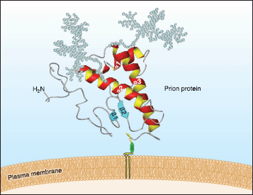
PrPSc
The abnormal, disease-producing protein
is called PrPSc (for scrapie)
has the same amino acid sequence as the normal protein; that is, their primary structures are identical but
its secondary structure is dominated by beta conformation
is insoluble in all but the strongest solvents
is highly resistant to digestion by proteases
When PrPSc comes in contact with PrPC, it converts the PrPC into more of itself (even in the test tube).
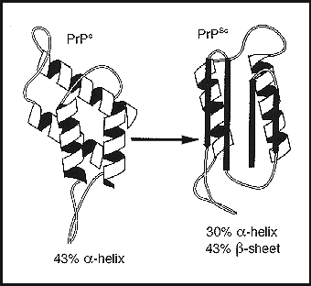
These molecules bind to each other forming aggregates.
It is not yet clear if these aggregates are themselves the cause of the cell damage or are simply a side effect of the underlying disease process.
Inherited Prion Diseases
Creutzfeldt-Jakob Disease (CJD)
10–15% of the cases of CJD are inherited; that is, the patient comes from a family in which the disease has appeared before.
The disease is inherited as an autosomal dominant.

The patients have inherited at least one copy of a mutated PRNP gene. Some of the most common mutations are:
a change in codon 200 converting glutamic acid (E) at that position to lysine (K) (thus designated "E200K") [link to a table giving the single-letter code for the amino acids]
a change from aspartic acid (D) at position 178 in the protein to asparagine (D178N) when it is accompanied by a polymorphism in both PRNP genes that encodes valine at position 129. (When the polymorphism at codon 129 is Met on both genes, the D178N mutation produces Fatal Familial Insomnia instead.)
a change from valine (V) at position at position 210 to isoleucine (V210I)
Extracts of autopsied brain tissue from these patients can transmit the disease to
apes (whose PRNP gene is probably almost identical to that of humans).
transgenic mice who have been given a Prnp gene that contains part of the human sequence.
These results lead to the important realization that prion diseases can only be transmitted to animals that already carry a PRNP gene with a sequence that is at least similar to the one that encoded the PrPSc. In fact, knockout mice with no Prnp genes at all cannot be infected by PrPSc.
Gerstmann-Sträussler-Scheinker disease (GSS)
This prion disease is caused by the inheritance of a PRNP gene with a mutations encoding most commonly
leucine instead of proline at position 102 (P102L) or
valine instead of alanine at position 117 (A117V)
Again, the disease is also strongly associated with homozygosity for a polymorphism at position 129 (both residues being methionine).

Brain extracts from patients with GSS can transmit the disease to
monkeys and apes
transgenic mice containing a portion of the human PRNP gene.
Transgenic mice expressing the P102L gene develop the disease spontaneously.
Fatal Familial Insomnia (FFI)
People with this rare disorder have inherited
a PRNP gene with asparagine instead of aspartic acid encoded at position 178 (D178N)
the susceptibility polymorphism of methionine at position 129 of the PRNP genes.
Extracts from autopsied brains of FFI victims can transmit the disease to transgenic mice.
Infectious Prion Diseases
Kuru
Kuru was once found among the Fore tribe in Papua New Guinea whose rituals included eating the brain tissue of recently deceased members of the tribe. Since this practice was halted, the disease has disappeared.
Before then, the disease was studied by transmitting it to chimpanzees using injections of autopsied brain tissue from human victims.

Scrapie
This disease of sheep (and goats) was the first TSE to be studied. It seems to be transmitted from animal to animal in feed contaminated with nerve tissue. It can also be transmitted by injection of brain tissue.
Bovine Spongiform Encephalopathy (BSE) or "Mad Cow Disease"
An epidemic of this disease began in Great Britain in 1985 and before it was controlled, some 800,000 cattle were sickened by it. Its origin appears to have been cattle feed that
contained brain tissue from sheep infected with scrapie and
had been treated in a new way that no longer destroyed the infectiousness of the scrapie prions.
The use of such food was banned in 1988 and after peaking in 1992, the epidemic declined quickly.
Creutzfeldt-Jakob Disease (CJD)
A number of humans have acquired CJD through accidental exposure to material contaminated with CJD prions.
Grafts of dura mater taken from patients with inherited CJD have transmitted the disease to several hundred recipients.
Corneal transplants have also inadvertently transmitted CJD.
Instruments used in brain surgery on patients with CJD have transmitted the disease to other patients. Two years after their supposed sterilization, these instruments remained infectious.
Several hundred people have acquired CJD from injections of human growth hormone (HGH) or human gonadotropins prepared from pooled pituitary glands that inadvertently included glands taken from humans with CJD.
Now that both HGH and human gonadotropins are available through recombinant DNA technology, such disastrous accidents need never recur.

Variant Creutzfeldt-Jakob Disease (vCJD)
This human disorder appeared some years after the epidemic of BSE (Mad Cow Disease) swept through the cattle herds in Great Britain. Even though the cow and human PRNP genes differ at 30 codons, the sequence of their prions suggests that these patients (155 by 2005) acquired the disease from eating contaminated beef.

All the patients are homozygous for the susceptibility polymorphism of methionine at position 129.

The BSE epidemic has waned, and slaughter techniques that allow cattle nervous tissue in beef for human consumption have been banned since 1989. Now we must wait to see whether more cases of vCJD are going to emerge or whether the danger is over.

Miscellaneous Infectious Prion Diseases
A number of TSEs have been found in other animals.
Cats are susceptible to Feline Spongiform Encephalopathy (FSE)
Mink are also susceptible to a TSE.
Even though mad cow disease has not been seen in North America, a similar disease — called chronic wasting disease — is found in elk and mule deer in the Rocky Mountains of the U.S.
Sporadic Prion Diseases
CJD and FFI occasionally occur in people who have no family history of the disease and no known exposure to infectious prions. The cause of their disease is uncertain.
Perhaps a spontaneous somatic mutation has occurred in one of the PRNP genes in a cell.
Perhaps their normal PrPC protein has spontaneously converted into the PrPSc form.
Or perhaps the victims were simply unknowingly exposed to infectious prions, and sporadic prion diseases do not exist!
Whatever the answer, all the cases are found in people with a susceptibility polymorphism in their PRNP genes.

바이러스

-capsid, envelope
-RNA virus, DNA virus
-HIV: RNA virus CD4
CD4 ( cluster of differentiation 4) is a glycoprotein found on the surface of immune cells such as T helper cells, monocytes, macrophages, and dendritic cells.

CD4 is a co-receptor of the T cell receptor (TCR) and assists the latter in communicating with antigen-presenting cells. The TCR complex and CD4 each bind to distinct regions of the antigen-presenting MHCII molecule - α1/β1 and β2, respectively.

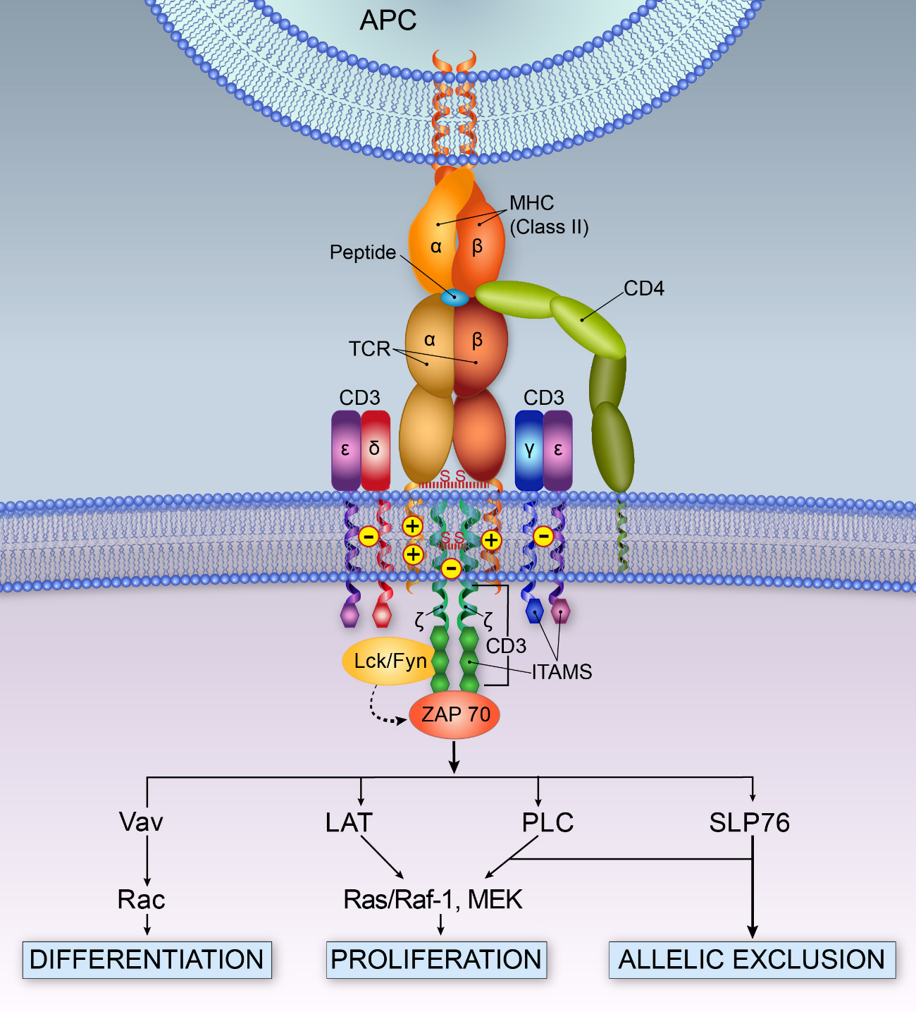
- 수두 바이러스의 비활성 잠복상태: 대상포진
Human alphaherpesvirus 3, often called varicella-zoster virus (VZV), is one of eight herpesviruses known to infect humans. It causes chickenpox (varicella), a disease most commonly affecting children, teens, and young adults, and shingles (herpes zoster) in adults; shingles is rare in children. VZV is a worldwide pathogen known by many names: chickenpox virus, varicella virus, zoster virus, and Human herpesvirus 3 (HHV-3). VZV infections are species-specific to humans, but can survive in external environments for a few hours, maybe a day or two.

The genome was first sequenced in 1986.[9] It is a linear duplex DNA molecule, a laboratory strain has 124,884 base pairs.
Shingles, also known as zoster or herpes zoster, is a viral disease characterized by a painful skin rash with blisters in a localized area.[2][6] Typically the rash occurs in a single, wide stripe either on the left or right side of the body or face.[1] Two to four days before the rash occurs there may be tingling or local pain in the area.[1][7] Otherwise there are typically few symptoms though some may have fever, headache, or feel tired.[1][8] The rash usually heals within two to four weeks;[2] however, some people develop ongoing nerve pain which can last for months or years, a condition called postherpetic neuralgia (PHN).[1] In those with poor immune function the rash may occur widely.[1] If the rash involves the eye, vision loss may occur.[2][9]

HPV

HPV is a small double-stranded circular DNA virus with a genome of approximately 8000 base pairs

Human papillomavirus infection (HPV infection) is an infection by human papillomavirus (HPV).[4] Most HPV infections cause no symptoms and resolve spontaneously.[1] In some people, an HPV infection persists and results in warts or precancerous lesions.[2] The precancerous lesions increase the risk of cancer of the cervix, vulva, vagina, penis, anus, mouth, or throat.[1][2] Nearly all cervical cancer is due to HPV with two types, HPV16 and HPV18, accounting for 70% of cases.

Coronaviruses are a group of related RNA viruses that cause diseases in mammals and birds. In humans and birds, they cause respiratory tract infections that can range from mild to lethal. Mild illnesses in humans include some cases of the common cold (which is also caused by other viruses, predominantly rhinoviruses), while more lethal varieties can cause SARS, MERS, and COVID-19. In cows and pigs they cause diarrhea, while in mice they cause hepatitis and encephalomyelitis. There are as yet no vaccines or antiviral drugs to prevent or treat human coronavirus infections.
Coronaviruses constitute the subfamily Orthocoronavirinae, in the family Coronaviridae, order Nidovirales, and realm Riboviria.^{[6][7]} They are enveloped viruses with a positive-sense single-stranded RNA genome and a nucleocapsid of helical symmetry.^{[8]} The genome size of coronaviruses ranges from approximately 26 to 32 kilobases, one of the largest among RNA viruses.^{[9]} They have characteristic club-shaped spikes that project from their surface, which in electron micrographs create an image reminiscent of the solar corona, from which their name derives.^{[10]}

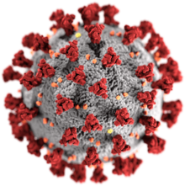
세균
- 세포외 기생

- 세포내 기생:

원생생물, 곰팡이, 연충류

- 말라리아
--아메바증
Amoebiasis, also known amoebic dysentery, is an infection caused by any of the amobae of the Entamoeba group.[3] Symptoms are most common during infection by Entamoeba histolytica.[3] Amoebiasis can be present with no, mild, or severe symptoms.[3] Symptoms may include abdominal pain, diarrhea, or bloody diarrhea.[3] Complications can include inflammation and ulceration of the colon with tissue death or perforation, which may result in peritonitis.[3] People affected may develop anemia due to loss of blood

-편모충증
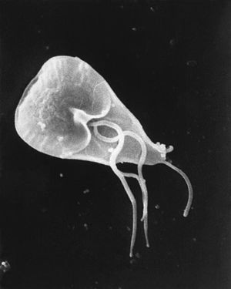
Giardiasis, popularly known as beaver fever,[3] is a parasitic disease caused by Giardia lamblia.[4] About 10% of those infected have no symptoms.[1] When symptoms occur they may include diarrhea, abdominal pain, and weight loss.[1] Vomiting, blood in the stool, and fever are less common.[1] Symptoms usually begin 1 to 3 weeks after exposure and without treatment may last up to six weeks.

-리슈메니어증
Leishmaniasis is a disease caused by parasites of the Leishmania type.[2] It is spread by the bite of certain types of sandflies.[2] The disease can present in three main ways: cutaneous, mucocutaneous, or visceral leishmaniasis.[2] The cutaneous form presents with skin ulcers, while the mucocutaneous form presents with ulcers of the skin, mouth, and nose, and the visceral form starts with skin ulcers and then later presents with fever, low red blood cells, and enlarged spleen and liver

-톡소플라즈마증
Toxoplasmosis is a parasitic disease caused by Toxoplasma gondii.[3] Infections with toxoplasmosis usually cause no obvious symptoms in adults.[2] Occasionally, people may have a few weeks or months of mild, flu-like illness such as muscle aches and tender lymph nodes.[1] In a small number of people, eye problems may develop.[1] In those with a weak immune system, severe symptoms such as seizures and poor coordination may occur.[1] If infected during pregnancy, a condition known as congenital toxoplasmosis may affect the child

-트리코모나스증
Trichomoniasis (trich) is an infectious disease caused by the parasite Trichomonas vaginalis.[2] About 70% of women and men do not have symptoms when infected.[2] When symptoms do occur they typically begin 5 to 28 days after exposure.[1] Symptoms can include itching in the genital area, a bad smelling thin vaginal discharge, burning with urination, and pain with sex.[1][2] Having trichomoniasis increases the risk of getting HIV/AIDS.[1] It may also cause complications during pregnancy

-수면병
Trypanosomiasis or trypanosomosis is the name of several diseases in vertebrates caused by parasitic protozoan trypanosomes of the genus Trypanosoma.[citation needed] In humans this includes African trypanosomiasis and Chagas disease. A number of other diseases occur in other animals

- 무좀

-표피사상균속
Epidermophyton is a genus of fungus causing superficial and cutaneous mycoses, including E. floccosum, and causes tinea corporis (ringworm), tinea cruris (jock itch), tinea pedis (athlete’s foot), and tinea unguium (fungal infection of the nail bed)

-소포자균속
Microsporum is a genus of fungi that causes tinea capitis, tinea corporis, ringworm, and other dermatophytoses (fungal infections of the skin). Microsporum forms both macroconidia (large asexual reproductive structures) and microconidia (smaller asexual reproductive structures) on short conidiophores. Macroconidia are hyaline, multiseptate, variable in form, fusiform, spindle-shaped to obovate, 7–20 by 30–160 um in size, with thin or thick echinulate to verrucose cell walls. Their shape, size and cell wall features are important characteristics for species identification. Microconidia are hyaline, single-celled, pyriform to clavate, smooth-walled, 2.5–3.5 by 4–7 um in size and are not diagnostic for any one species

-백선균속
Trichophyton is a genus of fungi, which includes the parasitic varieties that cause tinea, including athlete's foot, ringworm, jock itch, and similar infections of the nail, beard, skin and scalp. Trichophyton fungi are molds characterized by the development of both smooth-walled macro- and microconidia. Macroconidia are mostly borne laterally directly on the hyphae or on short pedicels, and are thin- or thick-walled, clavate to fusiform, and range from 4 to 8 by 8 to 50 μm in size. Macroconidia are few or absent in many species. Microconidia are spherical, pyriform to clavate or of irregular shape, and range from 2 to 3 by 2 to 4 μm in size
-캔디다증
Candidiasis is a fungal infection due to any type of Candida (a type of yeast).[2] When it affects the mouth, it is commonly called thrush.[2] Signs and symptoms include white patches on the tongue or other areas of the mouth and throat.[3] Other symptoms may include soreness and problems swallowing.[3] When it affects the vagina, it is commonly called a yeast infection.[2] Signs and symptoms include genital itching, burning, and sometimes a white "cottage cheese-like" discharge from the vagina.[8] Yeast infections of the penis are less common and typically present with an itchy rash.[8] Very rarely, yeast infections may become invasive, spreading to other parts of the body.[9] This may result in fevers along with other symptoms depending on the parts involved
-아스퍼질러스증
Aspergillosis is the name given to a wide variety of diseases caused by infection by fungi of the genus Aspergillus. The majority of cases occur in people with underlying illnesses such as tuberculosis[1] or chronic obstructive pulmonary disease, but with otherwise healthy immune systems.[2] Most commonly, aspergillosis occurs in the form of chronic pulmonary aspergillosis (CPA), aspergilloma or allergic bronchopulmonary aspergillosis (ABPA).[3] Some forms are intertwined; for example ABPA and simple aspergilloma can progress to CPA.

-효모균증
Cryptococcosis, also known as cryptococcal disease, is a potentially fatal fungal disease. It is caused by one of two species; Cryptococcus neoformans and Cryptococcus gattii. These were all previously thought to be subspecies of C. neoformans but have now been identified as distinct specie

-The nematodes (UK: /ˈnɛmətoʊdz/, US: /ˈniːməˌtoʊdz/) or roundworms constitute the phylum Nematoda (also called Nemathelminthes).[2][3] They are a diverse animal phylum inhabiting a broad range of environments. Taxonomically, they are classified along with insects and other moulting animals in the clade Ecdysozoa, and unlike flatworms, have tubular digestive systems with openings at both ends

-Cestoda is a class of parasitic worms in the flatworm phylum (Platyhelminthes). Most of the species - and the best-known - are those in the subclass Eucestoda; they are ribbonlike worms as adults, known as tapeworms. Their bodies consist of many similar units, known as proglottids, which are essentially packages of eggs which are regularly shed into the environment to infect other organisms. Species of the other subclass, Cestodaria, are mainly fish parasites

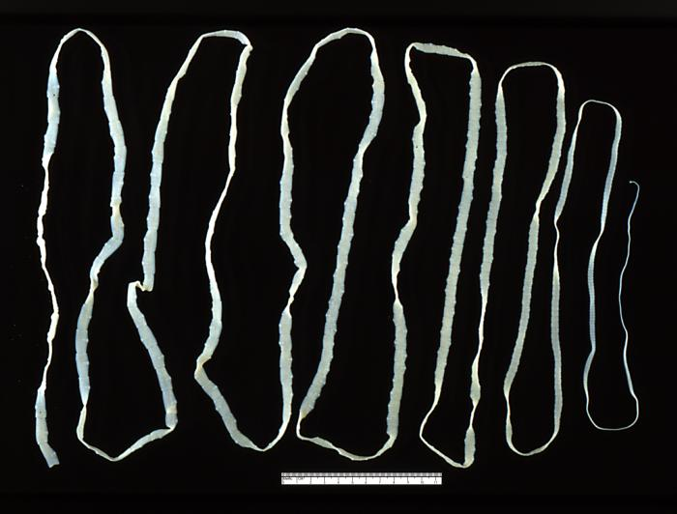
-디스토마류
Trematoda is a class within the phylum Platyhelminthes. It includes two groups of parasitic flatworms, known as flukes.

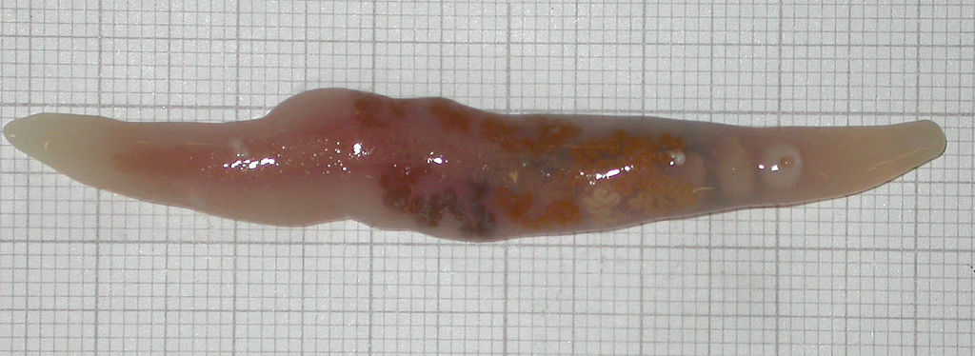

-주혈흡충
Schistosoma is a genus of trematodes, commonly known as blood flukes. They are parasitic flatworms responsible for a highly significant group of infections in humans termed schistosomiasis, which is considered by the World Health Organization as the second-most socioeconomically devastating parasitic disease (after malaria), with hundreds of millions infected worldwide
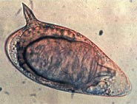

-흡충류: 간흡충 폐흡충 장흡충 주혈흡충

절지동물 척추동물

-직접기생

-매개자
진드기
Lyme disease, also known as Lyme borreliosis, is an infectious disease caused by a bacterium named Borrelia spread by ticks.[2] The most common sign of infection is an expanding area of redness on the skin, known as erythema migrans, that appears at the site of the tick bite about a week after it occurred.[1] The rash is typically neither itchy nor painful.[1] Approximately 70–80% of infected people develop a rash.[1] Other early symptoms may include fever, headache and tiredness.[1] If untreated, symptoms may include loss of the ability to move one or both sides of the face, joint pains, severe headaches with neck stiffness, or heart palpitations, among others.[1] Months to years later, repeated episodes of joint pain and swelling may occur.[1] Occasionally, people develop shooting pains or tingling in their arms and legs.[1] Despite appropriate treatment, about 10 to 20% of people develop joint pains, memory problems, and tiredness for at least six months

쥐벼룩
Yersinia pestis[1] (formerly Pasteurella pestis) is a gram-negative, nonmotile, rod-shaped coccobacillus bacteria, with no spores. It is a facultative anaerobic organism that can infect humans via the Oriental rat flea.[2] It causes the disease plague, which takes three main forms: pneumonic, septicemic and bubonic plagues.[2][3][4] All three forms were responsible for a number of high-mortality epidemics throughout human history, including: the sixth century's Plague of Justinian; the Black Death, which accounted for the death of at least one-third of the European population between 1347 and 1353; and the Third Pandemic, sometimes referred to as the Modern Plague, which began in the late nineteenth century in China and spread by rats on steamboats claiming close to 10,000,000 lives.[5][6][7][8] These plagues likely originated in China and were transmitted west via trade routes.[8][9] Recent research indicates that the pathogen may have been the cause of what is described as the Neolithic Decline, when European populations declined significantly.[10] This would push the date to much earlier and might be indicative of an origin in Europe rather than Eurasia.

-동물
광견병
Rabies lyssavirus, formerly Rabies virus, is a neurotropic virus that causes rabies in humans and animals. Rabies transmission can occur through the saliva of animals and less commonly through contact with human saliva. Rabies lyssavirus, like many rhabdoviruses, has an extremely wide host range. In the wild it has been found infecting many mammalian species, while in the laboratory it has been found that birds can be infected, as well as cell cultures from mammals, birds, reptiles and insects

The genetic information is packaged as a ribonucleoprotein complex in which RNA is tightly bound by the viral nucleoprotein. The RNA genome of the virus encodes five genes whose order is highly conserved. These genes code for nucleoprotein (N), phosphoprotein (P), matrix protein (M), glycoprotein (G) and the viral RNA polymerase (L).[3] The complete genome sequences range from 11,615 to 11,966 nt in length
-옴(진드기)

-흡혈충

2.3 병원성 인자

-일반적 인자

-벙어적 인자

-공격적 인자

방어적 병원성 인자

-점액층

-피막(캡슐)

-숙주세포 표면 분자 모방

-면역계혼란

-면역계 회피:

공격적 병원성 인자
-adhesin

-invasin

-toxin:

-enzymes

superantigen

순활물기생체

조건부기생체

절대세포내기생체

조건부세포내기생체

독소:

외독소

내독소

retrograde axonal transport
anterograde

2.4 감염과정
부착, 진입, 국소감염, 확대감염

Botulinum toxin
Botulinum toxin (BTX) is a neurotoxic protein produced by the bacterium Clostridium botulinum and related species.[1] It prevents the release of the neurotransmitter acetylcholine from axon endings at the neuromuscular junction and thus causes flaccid paralysis.[2] Infection with the bacterium causes the disease botulism. The toxin is also used commercially in medicine, cosmetics and research.

Botulinum is the most acutely lethal toxin known, with an estimated human median lethal dose (LD50) of 1.3–2.1 ng/kg intravenously or intramuscularly and 10–13 ng/kg when inhaled.[3][clarification needed]

There are eight types of botulinum toxin, named type A–H. Types A and B are capable of causing disease in humans, and are also used commercially and medically.[4] Types C–G are less common; types E and F can cause disease in humans, while the other types cause disease in other animals.[5] Type H is considered the deadliest substance in the world – an injection of only 2 ng can cause death to an adult.[6] Botulinum toxin types A and B are used in medicine to treat various muscle spasms and diseases characterized by overactive muscle. Commercial forms are marketed under the brand names Botox and Dysport, among others.[7][8]

Mechanism of action

Target molecules of botulinum neurotoxin (abbreviated BoNT) and tetanus neurotoxin (TeNT), toxins acting inside the axon terminal.[36]
Botulinum toxin exerts its effect by cleaving key proteins required for nerve activation. First, the toxin binds specifically to nerves which use the neurotransmitter acetylcholine. Once bound to the nerve terminal, the neuron takes up the toxin into a vesicle by receptor-mediated endocytosis.[37] As the vesicle moves farther into the cell, it acidifies, activating a portion of the toxin which triggers it to push across the vesicle membrane and into the cell cytoplasm.[1] Once inside the cytoplasm, the toxin cleaves SNARE proteins, meaning that the acetylcholine vesicles can’t bind to the intracellular cell membrane,[37] preventing the cell from releasing vesicles of neurotransmitter. This stops nerve signaling, leading to paralysis.[1]

The toxin itself is released from the bacterium as a single chain, then becomes activated when cleaved by its own proteases.[12] The active form consists of a two-chain protein composed of a 100-kDa heavy chain polypeptide joined via disulfide bond to a 50-kDa light chain polypeptide.[38] The heavy chain contains domains with several functions: it has the domain responsible for binding specifically to presynaptic nerve terminals, as well as the domain responsible for mediating translocation of the light chain into the cell cytoplasm as the vacuole acidifies.[1][38] The light chain is a zinc metalloprotease and is the active part of the toxin. It is translocated into the host cell cytoplasm where it cleaves the host protein SNAP-25, a member of the SNARE protein family which is responsible for fusion. The cleaved SNAP-25 is unable to mediate fusion of vesicles with the host cell membrane, thus preventing the release of the neurotransmitter acetylcholine from axon endings.[1] This blockage is slowly reversed as the toxin loses activity and the SNARE proteins are slowly regenerated by the affected cell.[1]

The seven toxin types (A-G) have different tertiary structures and sequence differences.[38][39] While the different toxin types all target members of the SNARE family, different toxin types target different SNARE family members.[36] The A, B, and E serotypes cause human botulism, with the activities of types A and B enduring longest in vivo (from several weeks to months).

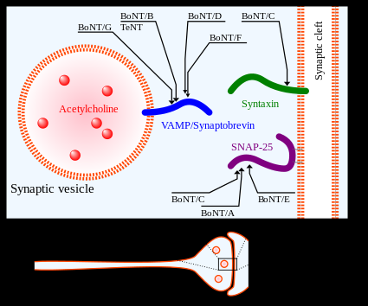

cholera toxin
The cholera toxin is an oligomeric complex made up of six protein subunits: a single copy of the A subunit (part A, enzymatic), and five copies of the B subunit (part B, receptor binding), denoted as AB5. Subunit B binds while subunit A activates the G protein which activates adenylate cyclase. The three-dimensional structure of the toxin was determined using X-ray crystallography by Zhang et al. in 1995.[5]

The five B subunits—each weighing 11 kDa, form a five-membered ring. The A subunit which is 28 kDa, has two important segments. The A1 portion of the chain (CTA1) is a globular enzyme payload that ADP-ribosylates G proteins, while the A2 chain (CTA2) forms an extended alpha helix which sits snugly in the central pore of the B subunit ring.[6]

This structure is similar in shape, mechanism, and sequence to the heat-labile enterotoxin secreted by some strains of the Escherichia coli bacterium

Cholera toxin acts by the following mechanism: First, the B subunit ring of the cholera toxin binds to GM1 gangliosides on the surface of target cells. The B subunit can also bind to cells lacking GM1. The toxin then most likely binds to other types of glycans, such as Lewis Y and Lewis X, attached to proteins instead of lipids.[7][8][9] Once bound, the entire toxin complex is endocytosed by the cell and the cholera toxin A1 (CTA1) chain is released by the reduction of a disulfide bridge. The endosome is moved to the Golgi apparatus, where the A1 protein is recognized by the endoplasmic reticulum chaperone, protein disulfide isomerase. The A1 chain is then unfolded and delivered to the membrane, where Ero1 triggers the release of the A1 protein by oxidation of protein disulfide isomerase complex.[10] As the A1 protein moves from the ER into the cytoplasm by the Sec61 channel, it refolds and avoids deactivation as a result of ubiquitination.

CTA1 is then free to bind with a human partner protein called ADP-ribosylation factor 6 (Arf6); binding to Arf6 drives a change in the shape of CTA1 which exposes its active site and enables its catalytic activity.[11] The CTA1 fragment catalyses ADP-ribosylation of the Gs alpha subunit (Gαs) proteins using NAD. The ADP-ribosylation causes the Gαs subunit to lose its catalytic activity of GTP hydrolization into GDP + Pi, thus maintaining Gαs in its activated state. Increased Gαs activation leads to increased adenylate cyclase activity, which increases the intracellular concentration of 3',5'-cyclic AMP (cAMP) to more than 100-fold over normal and over-activates cytosolic PKA. These active PKA then phosphorylate the cystic fibrosis transmembrane conductance regulator (CFTR) chloride channel proteins, which leads to ATP-mediated efflux of chloride ions and leads to secretion of H2O, Na+, K+, and HCO3− into the intestinal lumen. In addition, the entry of Na+ and consequently the entry of water into enterocytes are diminished. The combined effects result in rapid fluid loss from the intestine, up to 2 liters per hour, leading to severe dehydration and other factors associated with cholera, including a rice-water stool.[12]

The pertussis toxin (also an AB5 protein) produced by Bordetella pertussis acts in a similar manner with the exception that it ADP-ribosylates the Gαi subunit, rendering it unable to inhibit cAMP production
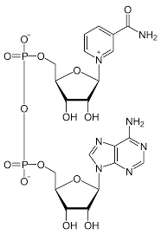

NAD 구조

